Project Apollo v4 – optimization and auto-tuning

Table of Contents

Problem statement 1

Goal 2

Theory of operation 2

Measured data 4

Controlled parameters 4

Optimization approaches 5

PSA process simulation 5

Device-in-loop optimization 6

Auto-tuning model 7

# Problem statement

COVID-19 patients with severe and critical conditions need respiratory support including bag-valve-mask ventilation, noninvasive mechanical ventilation (NIMV), high-flow nasal cannula oxygen (NFNO), mechanical ventilation and other protocols [1] [2] [3] [4]. In some cases, medical protocols also apply to COVID-19 patients in home care [5].

Medical equipment used in such scenarios needs a source of oxygen. Normally, medical-grade oxygen is available from distribution networks who provide it bottled form shipped to hospitals or care centers.

However, in developed countries, an oxygen distribution infrastructure is missing. In those cases, hospitals need to improvise make-shift medical oxygen generation sources.

This document details an oxygen generation design that addresses that gap. Apollo is an oxygen concentrator design that relies on the classical PSA (Pressure Swing adsorption) process, commonly used in commercial-grade oxygen concentrators.

A key goal of Apollo is reliance on low-cost materials and inexpensive tools. The device be built in large quantities using inexpensive materials and low skills in developed countries. The oxygen generator can be easily maintainable by local crews. It can be adapted to the particular needs (oxygen concentrator and flow) that the local medical care centers require.

# Goal

This document details the procedure for optimizing/fine-tuning parameters for optimal generation.

Out of the box, Apollo can provide 5 liters/minute oxygen-rich air with about 45% oxygen concentration. This is already good enough for the majority of COVID-19 patients.

However, critically-ill patients need higher concentrations of oxygen, as high as 90-93%.

**The goal of this document is to produce a generic optimization technique that can result in 5 liters/min @ 93% O2 concentration using the Prototype v4 Apollo setup (two 2L zeolite tanks with 13x zeolite).**

# Theory of operation

The design relies on a traditional PSA (pressure swing adsorption) technique using a cyclic Skarstrom approach. More details can be found in the Wikipedia [article](https://en.wikipedia.org/wiki/Pressure_swing_adsorption) or in [several](http://kexhu.people.ust.hk/ceng521/521-7.pdf) [documents](https://www.hindawi.com/journals/isrn/2012/982934/) [6].

One good reference to the industry-level designs of oxygen generation using PSA process can be found in this article[7].

In a nutshell, a PSA-based oxygen concentrator works by alternately injecting compressed air into two adsorption columns containing zeolite. Each of these two columns will adsorb some fraction of nitrogen from the air, thereby increasing the oxygen concentration in the remaining air, which is then exhausted through the other end of the column. The nitrogen is then purged in a subsequent step

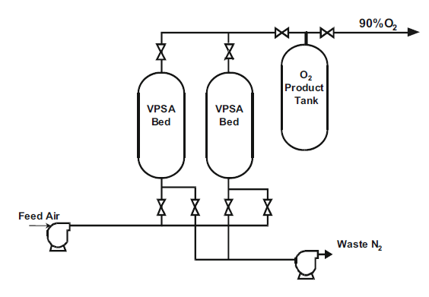

The two columns are being alternate in a six-step cycle (sometimes simplified down to a four-step cycle)

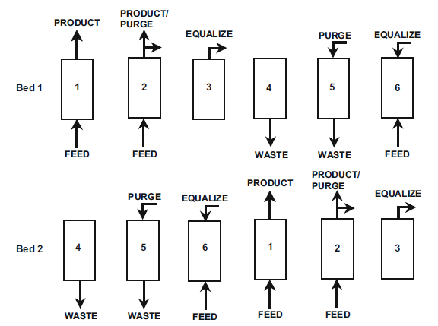

What is critical for the proper functionality of a PSA-based concentrator is to ensure the proper **timings** between each of these phases. Ensuring proper timings can result in a much higher O2 concentration being generated. For instance, alternating the columns too fast might not allow the nitrogen to be adsorbed. Alternating them too slow will overwhelm the standby air with too much nitrogen, again reducing the final oxygen concentration.

Typically, an adsorption half-cycle takes a 10-20 seconds, with a small equalization step in between. The Ackley article details various cycle combinations that are used in the industry.

There are other parameters to be controlled such as the input pressure (compressed air). The input pressure needs to be not too high or too low otherwise the system either becomes harder to optimize, or the final flow of the oxygen air is too low.

Finally, there are other considerations that are not mentioned in this document such as the need to ensure that the incoming air is completely free of water and organic materials that may contaminate the zeolite columns. Also the air needs to be properly filtered and humidified in order to ensure compliance with medical standards for oxygen-rich air for patients.

# Measured data

The Apollo device has multiple sensors that can measure the following data points.

1. O2 concentration at output
2. Pressures at the zeolite tank input
3. Pressures at each tank output
4. Gas temperature at input
5. Gas temperature at output

The main goal is to run multiple test variations until we find an optimal configuration that maximizes O2 concentration at output.

A secondary goal is to ensure that we can reach this O2 concentration in a large variety of conditions such as ambient temperature, partial zeolite contamination and small differences in pressure drop in each zeolite column. What we want is a reliable timing adjustment process that will always reach the desired concentration.

# Controlled parameters

The following parameters can be adjusted/controlled to maximize oxygen concentration:

1. Input pressure (typically fixed somewhere in the interval of 25-35 psi gauge)
2. Output pressure (typically fixed in the interval of 5-10 psi)
3. Feed timing for each column (typically 10-20 seconds)
4. Equalization timing (~ 1s)
5. Purging timing (~ 1s)

# Optimization approaches

There are three optimization approaches

1. Theoretical model optimization (via simulation)
2. Device-in-loop optimization
3. Hybrid model

## PSA process simulation

In this approach the goal is first to produce a complete characterization of the physical system using a software model and then optimize the software model offline. At the end the optimal timings are applied in the physical system.

The advantage of this approach is that it can model and optimize the system quite accurately. The disadvantage is that this optimization is partially lost when there are variations between concentrators, for instance due to variable tube/valve properties, zeolite packing strength, partial zeolite contamination, etc. However, this approach is a good starting point for modelling the functionality of a PSA system.

The Apollo Github [location](https://github.com/oxycon/ProjectApollo/tree/master/simulation) contains a fairly complete software simulation package that can be used to simulate the functionality of the entire system.

**How it works:** The simulator uses models the PSA oxygen concentrator using different techniques and modes of operation. We have six modes of operation:

COL1 COL2

MODE Switch 5-way valve

half==0 and 1. Pressurize 1 pressurizing Vent

half==0 and 2. Produce 1 pressurize & output Vent

Open cross valve

half==0 and 3. CrossVent Pressurize, out to COL2 Vent

Close Cross valve and Switch 5-way valve

half==1 and 1. Pressure 2

half==1 and 2. Produce 2

Open cross valve

half==1 and 3. CrossVent 2

and repeat at top

It also contains a procedure for optimizing the simulated model using SciPy.

Here are some examples of simulated operational parameters of the concentrator

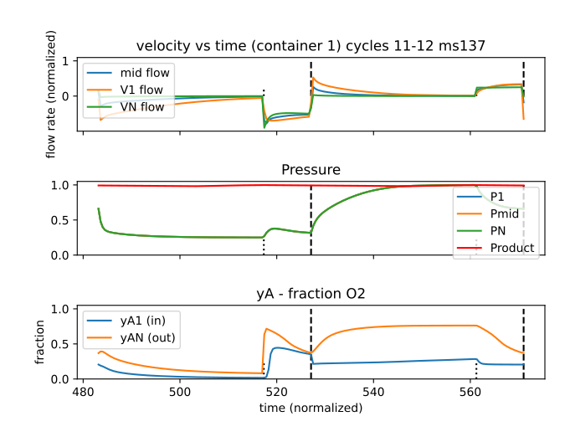

## Device-in-loop optimization

In this approach we use an automation “test rig” that subjects the PSA concentrator to a variety of conditions. We infer the optimized solution by walking in the state space of all the possible parameter combinations, fine-tuning them until we reach an optimal configuration.

The advantage of this approach is that it is exhaustive and always correct. The disadvantage is that building a test rig that uses automation to walk through all the possible combinations is expensive and wasteful. This method may not be practical in developing countries where the building and testing cost is an important criterion.

**How it works**: This technique kicks off the PSA process with a combination of timings, pressure thresholds and other system parameters. Multiple tries are being done until we find the proper timing combination that maximizes O2 concentration.

We will run multiple tests sequentially on the same prototype using slightly different parameters.

A test reset procedure will be performed before starting each test

1. Dump the contents of the O2 storage tank
2. Check for water separation

Process:

1. charge cycle timing (the half-cycle time interval)
   1. 6 seconds … 15 seconds with 0.5 second increment
2. flush time timing (the duration of the flush valve being open at the end of the cycle). This time interval is part of the charge cycle above.
   1. 0.1 to 3 seconds with 0.3 seconds increment
3. Regulated input pressure (manually adjusted)
   1. 15 to 25 psi with 2 psi increment
4. input flow rate (manually adjustable needle valve at the input of each tank).
   1. Actual measurement = psi increase per second at the end of the tank
5. Cross-tank bleeding orifice (if present in the configuration)
   1. Actual measurement = psi delta per second in the original tank after input removed
6. (when implemented in design) max zeolite tank pressure (when the max is reached, do not feed more air using a separate “stop feed” valve)

## Auto-tuning model

In this approach we infer the model parameters in software through constantly monitoring the device. Upon powering on, the device goes into a brief “training” period in which it learns the parameters of operation. After that, the device goes into a “ready” state in which it is able to serve oxygen at the desired configuration.

The advantage of this method is that it is self-adaptable to a variety of conditions. It does not assume tight control over the physical properties of the concentrator.

How it works: at high level, the auto-tuning approach combines the two approaches above. It relies on a partial (pre-simulated) neural network model of the concentrator which is used to resolve the actual timing parameters of the concentrator (using the second technique).

The main goal of the Apollo optimization effort is to implement a viable auto-tuning approach.

<TODO – insert more about auto-tuning>

1. Halacli, B., Kaya, A., & Topeli, A. (2020). Critically-ill COVID-19 patient. *Turkish journal of medical sciences*, *50*(SI-1), 585–591. <https://doi.org/10.3906/sag-2004-122>
2. Oxygenation and Ventilation, Module 4: Ventilation Management [American Heart Association] ([link](https://cpr.heart.org/-/media/cpr-files/resources/covid-19-resources-for-cpr-training/oxygenation-and-ventilation-of-covid-19-patients/ovcovid_mod4_vntmgmt_200401_ed.pdf?la=en&hash=DC07E68C015549A42991BC67BA674DB196D7EDC8))
3. COVID-19: Respiratory support outside the intensive care unit ([link](https://www.thelancet.com/pdfs/journals/lanres/PIIS2213-2600(20)30176-4.pdf))
4. Respiratory Support Strategies For Severe COVID-19 ([link](https://healthmanagement.org/c/icu/whitepaper/respiratory-support-strategies-for-severe-covid-19))
5. Covid-19 and the role of oxygen in palliative care at home ([link](https://www.cebm.net/covid-19/covid-19-and-the-role-of-oxygen-in-palliative-care-at-home/))
6. A [document](https://docs.google.com/document/d/1H08QvAtLe1W1NSTmdu_J57IfZpbp_WVVHQljT--lUuo/edit#heading=h.993onhfvf5) titled “Theory of operation” on Google Docs describes an optimized cycle. More research articles can be also found on Google Docs in a separate [folder](https://drive.google.com/drive/u/0/folders/1Xf_g52wBhaAFwEMlXoqpiL8xS9xUwcvg)
7. [Ackley] Medical oxygen concentrators a review of progress in air separation technology ([link](https://drive.google.com/file/d/1dPULuKNCiH3EcBG6xAv42wm_5slU8NQf/view?pli=1))